# Code of Conduct:

Mace Windu Code Of Conduct:

For the use and purpose of the Software Engineering module (KF5012) and use within the team Mace Windu, this document presents the code of conduct which is expected to be followed and respected by all participating team members:

Work Mentality and efforts:

* Members will be proactive. – In the form of communication and task completion, also if there are any times in which members may have future commitments or calendar clashes they shall inform the other team members. If this issue is of private and sensitive matter they are also able to inform the module tutor for sake of discomfort etc.
* All members shall treat each other with respect, while recognising each other as equals.
* All members shall keep the group as informed as possible with their accomplishments and hardships throughout personal tasks and missions.
* All team meetings will be notes and timed throughout the period of the project for clarity and productivity sake.

Decision making and risk taking:

* The team will make final milestone decisions as a team and have the time for constructive feedback and recommendations to enable to best options for moving forward.
* All team members will have an opportunity to put their point across before a final decision is made.
* Decisions will be based on their beneficial values to the team. Meaning that decisions will be based on facts and not on hopes etc. If any member doesn’t feel comfort in the suggested plan/option they shall ask for further explanation or potentially proof of its eligibility to the project.
* Final decisions will not be made without all team members having time to say their piece or without having input. If team members miss meetings they will be informed via teams of the decisions made and will be given time for response.

Communication:

* All members shall be honest and open about their capabilities & availability relating to the project.
* No member shall take on more than they believe they can handle.
* If a member starts to get overwhelmed with work they will seek help through the team. The team should then respond through potentially taking some of the weight/pressure of the member in question.
* Team members should be open and honest about conflict/disagreement to allow the tasks and project to be completed with efficiency, equal contribution and respect.
* Members shall contact module tutors if they believe there are issues in-which they are uncomfortable in communicating with team members.
* Team members shall be open and accepting of constructive comments and feedback to allow the best solutions to tasks and the project.

This code of conduct is agreed upon by the Mace Windu group, which is made up of:

Edward Davies

Harry Laws

Mariah Rodrigues

Ben Sisk

# Team Skills Audit:

Refer to skills audit folder within the Project Management Folder. This section includes each team members personal skills audit.

# Work Break Down Structure Of a Road Sign Classification System:

# Meeting Schedule:

The group have agreed to a meeting once a week, Tuesday at 2pm. These meetings were to be used as a drop in that can last around an hour long to see the progress, stresses, and further steps to take for each member. These meetings coincide with bi-weekly meetings with the module staff – Matt Higgs, the meetings typically were and are utilised for separate members questions about current mission plan of attacks/ techniques which can be adhered to.

Typically meeting minutes were not taken due to the relaxed approach of a free platform rather than rigorous structure. Information from meetings was and is taken by me (Edward Davies) but on a physical notepad. The information tailored to different members of the group was stored and noted individually and for larger tasks such as the group missions was and is appropriately noted and mentioned within the Software Engineering Teams chat dedicated to the group. This allowed people who missed meeting to still be kept in the loop of the group’s current affairs and tasks.

## Meeting File:

# Initial Gantt Chart Task Break Down & Timeline:

Ideal Work Breakdown Periods:

Real Work Breakdown Periods:

## Risk Matrix:

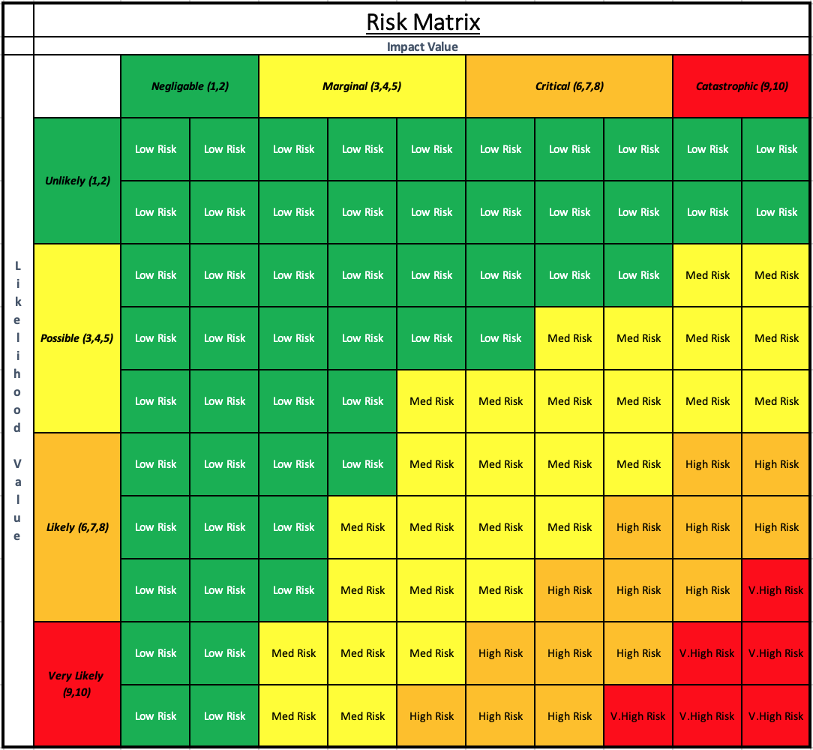

## Risk Definitions and documents the team go off:

### 3 Types of Risks:

* Those caused by the inherent difficulty in estimating
* Those due to assumptions made during the planning process
* Those of unforeseen (or at least unplanned) events occurring

### Boehm’s Top Ten list of Risk Items:

1. Personal Shortfalls
2. Unrealistic Schedules
3. Developing the wrong functions
4. Developing the wrong interface
5. Gold Plating
6. Continual Stream of Requirement changes
7. Shortfalls in externally furnished components
8. Shortfalls in externally performed tasks
9. Real-time performance shortfalls
10. Straining science capabilities

### Assigning Values to define risk categories:

There are two main input factors to calculate the Risk Exposure (RE)

1. Impact category:

The impact category & corresponding values are:

Negligible – 1,2

Marginal – 3,4,5

Critical – 6,7,8

Catastrophic – 9,10

1. Likelihood category

The likelihood category & corresponding values are:

Unlikely – 1,2

Possible – 3,4,5

Likely – 6,7,8

Very Likely – 9,10

The output of these two categories is the RE –

RE = Impact Value (IV) x Likelihood Value(LV)

Categories of the RE results are as follows:

* >= 75 Very High Risk
* >=50 < 75 High Risk
* >=25 < 50 Medium Risk
* <25 Low Risk

### Results and what to do next:

Once all off the above is taken into account and calculated, think about your own personal level of confidence in the RE value. If you are not comfortable with the value you can, take out more research which should either re-enforce the RE value or change it due to the new research etc. Another potential option if you are still unhappy with the result think about alternative options to either ease the risk or to completely eliminate this option etc. Re-evaluate.

### List of actions that can be taken:

* Avoid the risk
* Transfer the risk somewhere else
* Buy info about the risk
* Eliminate the root cause of the risk
* Assume the risk
* Publicise the risk
* Control the risk
* Remember the risk

## Risk Management Document:

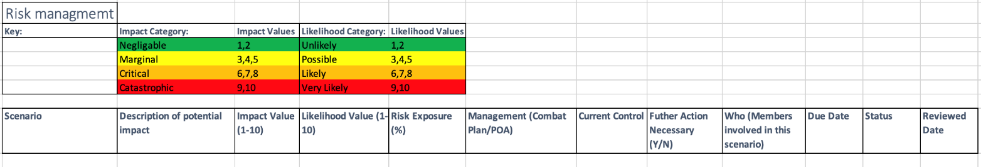

This is the format of the risk assessment excel spreadsheet file which was sent to each group member. This document was purposed to expose potential risks within each members tasks. It allowed each of us to comprehend the risks and how to go forward. These documents have been and continue to be cross referenced through out meetings and Teams chat discussions. An early example of the Document being used can be found within the Project Management Folder followed by the Risk Assessment folder. In there is Mariah Rodrigues’ risk assessment tailored to risks which she had noticed within her own tasks and also risks which were noticed for general group work.

The risks are calculated through the Impact and Likelihood value variables which are finally multiplied to calculate a risk exposure percentage. The risk exposure is able to be mapped onto the Risk matrix above. This visually allows risks to be mentally ranked, from risks to be tackled instantly Very High Risk, down to Low Risk.